You are a formatting and systems integration expert. I am uploading a combination of .json and .md files related to my AI project, NYRA, which spans across three main operational scopes:

#DevBuild (AI dev team architecture, orchestration, agents, IDEs, repo systems pertaining to the Dev systems, tools, modules, MCP servers, agents, frameworks, memory, etc. being used to code and develop the end product rather than anything pertaining to the end product itself. These are the initial systems being put in place.)

#MortgageAssistant (daily-use borrower communication, lead handling, and mortgage tools, anything having to do with day to day mortgage broker activities, mortgage loans, mortgage assistant, the end build of our Bonzo clone/ Nyra Mortgage Assistant, the Nyra Mortgage Assistant WebUI, development of Ratehunter.net web domain and landing page or anything involving Wix/Wix.com)

#Experimental (future integrations, bleeding-edge agents, local GPU deployments, MCP/UIs, anything that is talked about being planned for later down the road and not in the initial systems structure plans. This included Nyra TTS and voice to text setup to communicate with live borrowers on live calls and more. Anything being talked about in the document conversations as being not urgent or eventual implementations AFTER the main release for both my personal use and/or the release for my team and/or company at West Capital Lending.)

Your job is to:

🧩 Convert all content into:

Structured Notion-ready markdown with embedded tags for each section (#NYRA, #DevBuild, #Memory, #UI, #Experimental, etc.)

Individual modular .json files structured for database ingest — including key-value metadata, source reference, and relational structure suitable for:

memOS (short-term memory)

Graphiti + FalkorDB (long-term memory)

LMCache (token-saving inference cache)

RAG setup (LlamaIndex, GPT Index, or VectorDB-backed)

Claude memory routing and tagging (if applicable)

🗃️ Organize all content by system type and scope:

Memory Systems

Vector/Embedding Systems

Database Loaders (Dataloaders, LMCache, Graphiti ingest format)

Orchestration/Agent Management

File/System Management

UI/WebUI Interfaces

IDEs, Terminals, and Git Agents

Browser + TTS + TTV agents

MCPs / Local Agent-Deployment bridges (OpenEvolve, LettaAI, Think See Do, ManusAI, ArchonAI, DesktopCommanderMCP, KiloCode, AgentZero, etc.)

🧠 Requirements:

Convert all references and structure into usable input formats for the relevant database or vector engine.

Ensure Claude sections route and tag to all applicable categories — more is better, redundancy is not a problem.

Output all structured data for import to:

Notion

memOS MemoryCubes

Graphiti (JSONL or Neo4j format if required)

LlamaIndex or Weaviate/Chroma as vector inputs

VSCode-compatible repo files (optional)

📘 Output structure:

One master .md with clear headers, tags, and source hierarchy for manual inspection

JSON outputs split by type and destination (memory, db, UI, task, repo, etc.)

Recommendations on any missing structure or formatting inconsistencies
C:\Users\edane\scoop\apps\gitomatic\current
Siteonecrawler CLI install upon windows restart:
# download and unpack latest release
wget https://github.com/janreges/siteone-crawler/releases/download/v1.0.8/siteone-crawler-v1.0.8-macos-x64.tar.gz
tar -xvzf siteone-crawler-v1.0.8-macos-x64.tar.gz

# go to folder
cd siteone-crawler-v1.0.8-macos-x64

# run crawler with basic options
./crawler --url=https://crawler.siteone.io/

Meet UTCP: A new open standard for AI agents
UTCP (Universal Tool Calling Protocol) is a new open standard for AI agents, aiming to streamline tool calling by providing a lightweight alternative to MCP. It facilitates direct agent-to-tool calling by utilizing a straightforward JSON manifest to interface with native APIs. This method minimizes latency and avoids the "wrapper tax" associated with MCP. Although still in its nascent stages, UTCP holds promise for fostering a new ecosystem of AI agents and tools operating at lower latency.
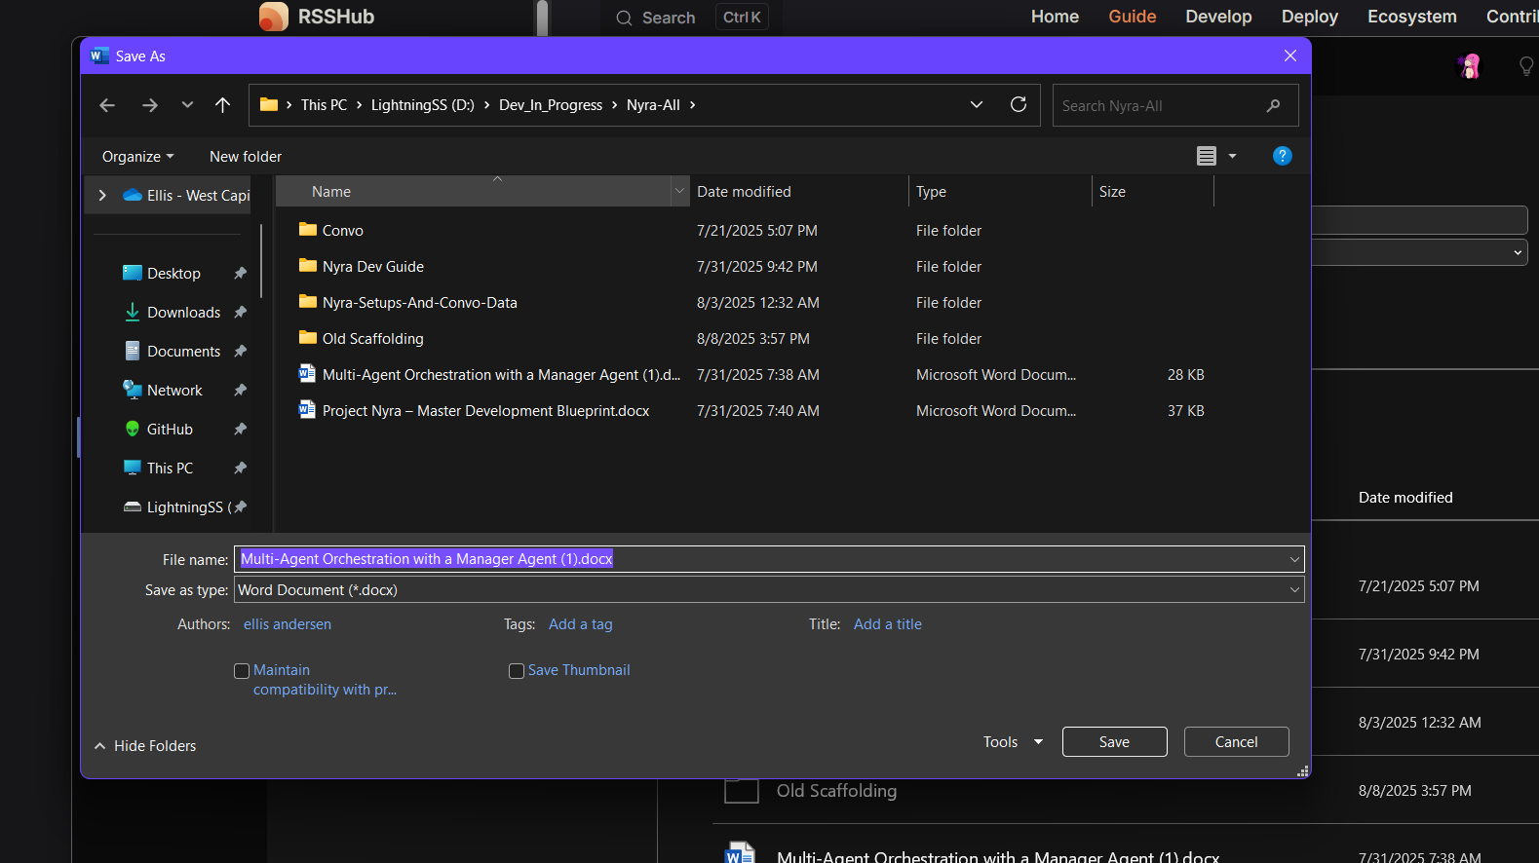

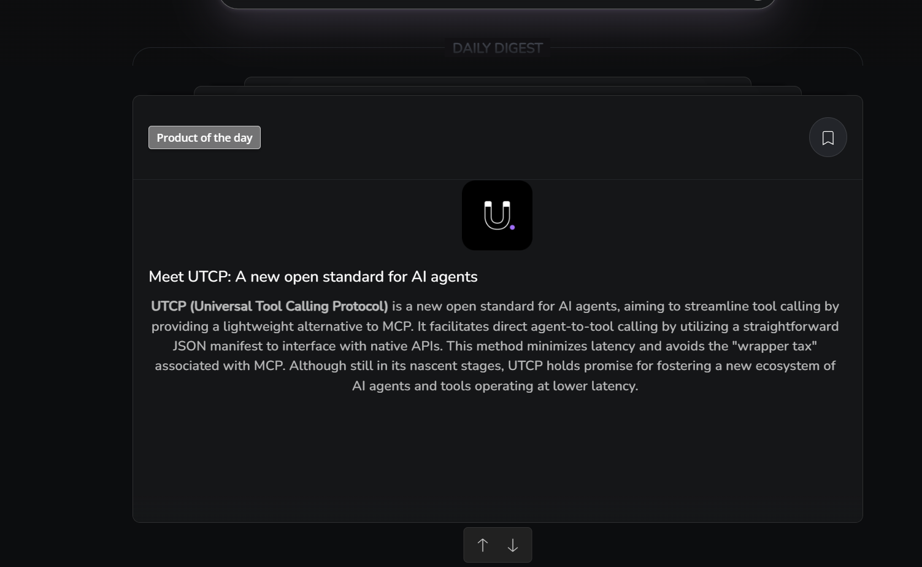
DAILY DIGEST

Docker 🐋

Why should you pin Docker images while using them in ML pipelines
  - Machine learning engineers should always pin Docker images in their docker-compose.yml files to ensure reproducibility and avoid unexpected breakages.
  - Floating tags, such as :latest, can lead to different runtime artifacts on different days or machines.
  - Pinning guarantees that every developer and experiment uses the same image contents.
  - While digest form is preferred for pinning, semantic tags can be used when digest is not available.

Explainers 📝

The cache-aside pattern: How to speed up your API calls
  - The cache-aside pattern, or lazy loading, is the secret sauce behind lightning-fast API calls.
  - It works by checking the cache first for requested items, only querying the slower database on a cache miss.
  - This pattern boosts read performance and lightens the load on databases.
  - However, it can lead to stale data and increased complexity for multi-writer systems.
  - It is perfect for read-heavy workloads with minimal business logic changes.

Programming languages 🖥️

For Python devs: Use pyenv-virtualenv to manage Python versions and projects
  - Pyenv-virtualenv is a powerful tool for Python developers, combining Python version management with per-project virtual environments.
  - It enables you to create and auto-activate isolated environments linked to a specific interpreter with simple commands.
  - This tool maintains project isolation, eliminates dependency conflicts, and prevents accidental global installs.
  - Plus, it offers lightweight flexibility compared to more comprehensive tools.
  - And, it supports automatic activation when you cd into a directory.
